1. Register Oracle VM 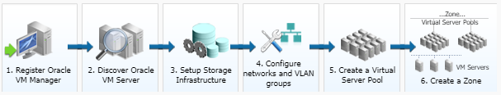Manager
The Oracle VM Manager provides the user interface that allows you to create and manage zones, virtual server pools, virtual servers, and guest virtual machines. Before you use the Oracle VM Manager to manage virtualization targets in Enterprise Manager, you must register an existing installation of the Oracle VM Manager.
2. Discover Oracle VM Server
A virtual server is a generic term used to describe a physical box which has virtualization software (hypervisor) running on it. A new virtual server can be provisioned by installing the OVM Hypervisor on a bare metal box. Before you add a virtual server to a server pool, it must be discovered.
3. Setup Storage Infrastructure
You can create external storage elements like storage servers, file systems, and Logical Unit Numbers (LUNs). An external storage element is created on dedicated storage hardware such as a server configured for NAS offering NFS shares. The server on which the storage element is present must be accessible by the Oracle VM Servers through a fibre channel or ethernet network.
4. Configure networks and VLAN groups
A network consists of a group of Oracle VM virtual server physical NIC ports. Virtual network interfaces (VNICs) are used to carry network traffic to virtual machines. You can generate MAC addresses that can be assigned to VNICs in a virtual machine. VLAN (Virtual Area Network) is a mechanism to virtualize network interfaces across subnets and physical locations so that they appear to be on a single confined LAN.
5. Create a Virtual Server Pool
A virtual server pool contains one or more virtual servers and Guest VMs. A virtual server can belong to only one virtual server pool at a time. Guest VMs are also associated with the server pools.
6. Create a Zone
A zone is used to group related cloud resources together. Zones can be created based on location, software lifecycle status, and so on to group resources belonging to a cost center or for metering and chargeback purposes. Typically, a zone can cover a department or possibly a small data center.

